## Merchant Demo date: October 9 2024 Scoping start date: Oct 15, 2024

MSA Signature Date: Oct 31, 2024  
Onboarding Kick Off Date: Nov 4, 2024

[If Exists] Opt Out Date: None  
Go Live Date: Nov 18, 2024

GTM POC: Ben  
Implementation POC: Ariel

ERP: QBO

Tax Integration: No Tax

### 

### Key people at Merchant

### Pleasant - COO

### 

| Notes Sections [Ops International Team to Ignore] *(AE/ Implementation to fill)*   * Info on how merchant bills   + to start, they will be doing Saas billing, no overages   + 20 customers by end of December - monthly payment, more than likely CC with stripe   + They are a consumption product but will not be doing a credit system to begin with * Is there any important merchant relationship information?   Pleasant and team have been easy to work with. Operator is a fellow Primary company |
| --- |

### 

### Company summary *(AE to fill)*

Operator.ai generates revenue by providing advanced AI-driven tools that streamline sales operations, emphasizing quality engagement over volume. By focusing on personalized, high-impact touches rather than traditional, repetitive outreach, the platform aims to improve how sales teams connect with potential clients.

Goals (North star)  
*(AE/ Implementation to fill)*

What is the merchant's goal? What pain are we solving? Why are they buying Tabs?  
The merchant is excited to put Tabs in place as their primary billing tool. They are bringing their first batch of paying customers on in late Nov/early December and want to have a system ready to handle with automation

Is there an opt out clause? If so, what is the merchant looking for so they do not exercise it?  
No Opt out clause

### Billing model *(AE/ Implementation to fill)*

* Are there unique things about the customer creation process for this merchant?
* Information on how merchant bills
* How contract is broken up
* One off things to know about the merchant

### Contract Processing Steps *(Implementation/Success to fill)*

1. Steps to process

**Please send Slackbot message for the first invoice of the billing sequence when the contract is processed.**

Initial contracts will come in the form of a quote

* Process all line items with amounts/qty
  + Item name from quote
  + Start date in quote
  + Service period in quote
  + Frequency in Billing Terms in quote
  + Integration item: Revenue: SaaS
  + Do not process $0 lines (there will be many)
* There is a section on the first page of the quote with contract billing terms
  + This will outline the payment cadence as well as any discounts
    - Discount will also be a line item at the bottom of the quote (more details on discounts below)
  + Please follow these guidelines, and flag if instructions are unclear
  + For these initial POC agreements, the billing terms and invoice cadence will vary. Most will have some sort of opt-out/autorenewal clause. In these situations, it is most important to refer to costs laid out in the invoice, because that is how billing should be set up, regardless of varying terms/opt out. For example:
    - If it will says quarterly with auto-renewal, but the charges are outlined for the full year, then we process this for a year, billed quarterly
    - If it says there is an opt out a few months in, but the quote lays out charges post opt-out, still process all charges laid out in the quote

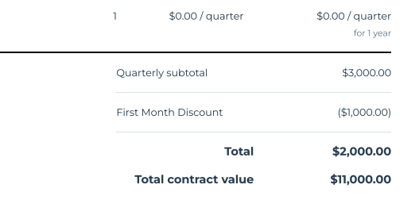

* Discounts - There will be a lot of discounts for these initial POC agreements. Rules might evolve on a case by case basis, so if it unclear how to process the discount, please flag!
* BUT, general rule of thumb:
  + If the invoicing is recurring for the same amount, but there is a discount on the first invoice, then process the discount as a separate BT (since there is no way to apply a discount to only 1 invoice in a recurring BT)
  + If the invoicing is set up where there are varying amounts between the first invoic and future invoices, then the discount can be applied directly to the first BT of the sequence. Example of this:
    - First invoice: 14,000 - Discount 3500
      * 84000/12 months=7k per month, so first 2 months are 14k
    - Second invoice: 70,000

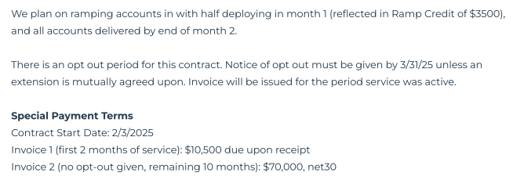

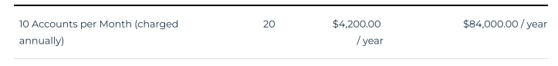

* Create new customers for contracts that come in (at this point, it will be very rare if a customer already exists, as they are just starting to bill for their product)
  + BIlling address is at the top of the quote
  + Billing contact is in its own section at the bottom of the first page of the quote

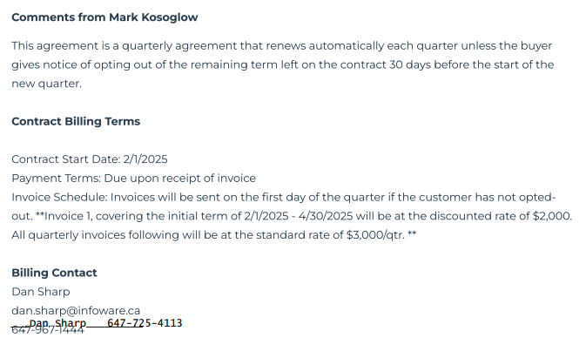

1. Anything to ignore in contracts?
2. Specifics processing things the merchant has requested that may differ by contract (e.g. always back-date invoice date to final day of the month)
3. Default Service Term
   1. If None Listed, Ops Default is 1 Year
4. Default Net Payment Terms
   1. If None, Ops Default is 0
5. Default Billing Frequency
   1. If None Listed, Ops Default is Monthly
6. How do we handle taxes as a line item?
   1. If None Listed, Ops Default is every tax line item becomes a BT

### Events Processing (if necessary) *(Implementation/Success to fill)*

* Any important information on events billing

Integration Items Processing (if necessary)  
*(Implementation/Success to fill)*

* What are the instructions for assigning integration items?
* Example: All Statsig integrations items should be labeled as “Sales”
* Example: All “Pinata” integration items should be labeled as “Software Subscription Bundle” unless otherwise noted by Merchant

Post Processing Communications (if necessary)  
*(Implementation/Success to fill)*

* Does the Ops Team need to notify anyone on the team re: completion of processing batches in Implementation or Active phase?
* Who needs to be notified and when?
  + Example:
    - Who: Customer Success [Azmat Aziz] needs to be notified
    - Where: Messari internal merchant channel
    - When: contracts are processed [Merchant Phase: Active]

### Customer Information *(Implementation/Success to fill)*

* Any important information on specifics customers of this merchant
  + Special memo’s certain invoices require
  + Invoice changes due to merchant/customer relationship

### Feature Requests *(AE/Implementation/Success to fill)*

* FR 1
  + What is it
  + Why it's important
  + Urgency

### Rewatch Calls *(AE/Implementation/Success to fill)*

* Our demo videos are lost in the archives of rewatch, but we do have our final conversation recorded aligning on price: <https://tabs.rewatch.com/video/nof30gikw03fmv9k-pleasant-ben-sync-on-tabs-pricing-october-30-2024>